Final Project
Rolando Ng
2025-11-25
data <- read.csv("CardioGoodFitness-2.csv")

1. Load Dataset and Metadata
head(data)
## Product Age Gender Education MaritalStatus Usage Fitness Income Miles
## 1 TM195 18 Male 14 Single 3 4 29562 112
## 2 TM195 19 Male 15 Single 2 3 31836 75
## 3 TM195 19 Female 14 Partnered 4 3 30699 66
## 4 TM195 19 Male 12 Single 3 3 32973 85
## 5 TM195 20 Male 13 Partnered 4 2 35247 47
## 6 TM195 20 Female 14 Partnered 3 3 32973 66
str(data) #Shows the structure of the dataset, including each variable’s type and example values.
## 'data.frame': 180 obs. of 9 variables:
## $ Product : chr "TM195" "TM195" "TM195" "TM195" ...
## $ Age : int 18 19 19 19 20 20 21 21 21 21 ...
## $ Gender : chr "Male" "Male" "Female" "Male" ...
## $ Education : int 14 15 14 12 13 14 14 13 15 15 ...
## $ MaritalStatus: chr "Single" "Single" "Partnered" "Single" ...
## $ Usage : int 3 2 4 3 4 3 3 3 5 2 ...
## $ Fitness : int 4 3 3 3 2 3 3 3 4 3 ...
## $ Income : int 29562 31836 30699 32973 35247 32973 35247 32973 35247 37521 ...
## $ Miles : int 112 75 66 85 47 66 75 85 141 85 ...
nrow(data) #Tells how many rows (customers) are in the dataset.
## [1] 180
ncol(data) #Tells how many columns (variables) the dataset contains.
## [1] 9
names(data) #Lists the names of all the variables in the dataset.
## [1] "Product" "Age" "Gender" "Education"
## [5] "MaritalStatus" "Usage" "Fitness" "Income"
## [9] "Miles"

2. Exploratory Data Analysis (EDA)

Categorical Data
table(data$Product) #Counts how many customers bought each treadmill model.
##
## TM195 TM498 TM798
## 80 60 40
barplot(table(data$Product), main="Treadmill Models", col="yellow") #Show the number of customers for each treadmill model.
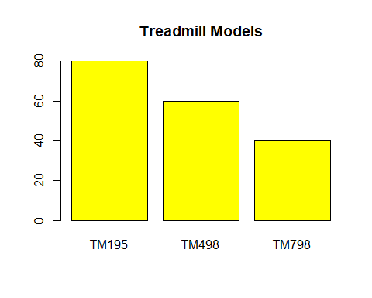
table(data$Gender) #Counts how many male and female customers there are.
##
## Female Male
## 76 104
barplot(table(data$Gender), main="Gender Count", col="pink") #Compare the number of male vs. female customers.
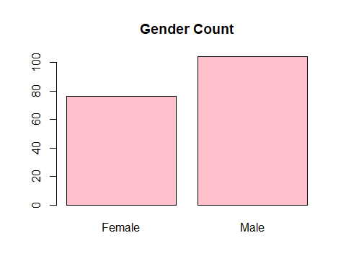
table(data$MaritalStatus) #Counts how many customers are single or partnered.
##
## Partnered Single
## 107 73
barplot(table(data$MaritalStatus), main="Marital Status", col="blue") #Show the number of customers in each marital status group.
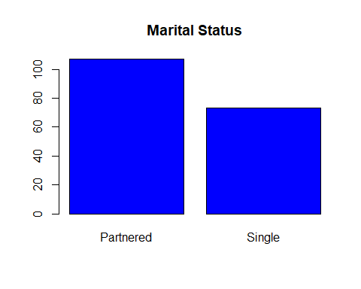

Numerical Data
hist(data$Age, main="Age Distribution", xlab="Age") #Shows which age ranges are most common.
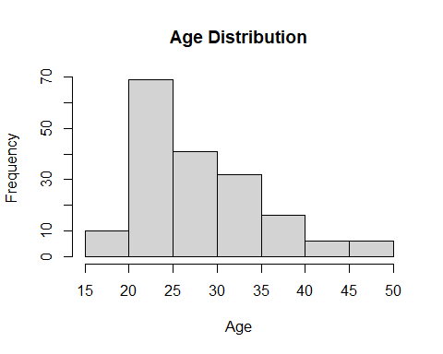
hist(data$Income, main="Income Distribution", xlab="Income") #Shows the spread of customer incomes and helps identify low, medium, and high earners.
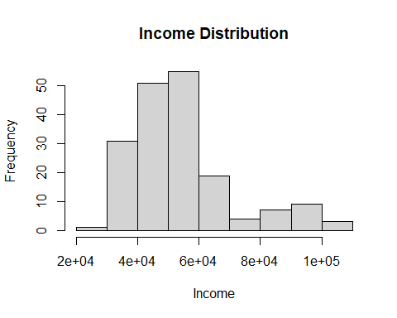
hist(data$Education, main="Education", xlab="Years") #Displays how many years of education customers typically have.
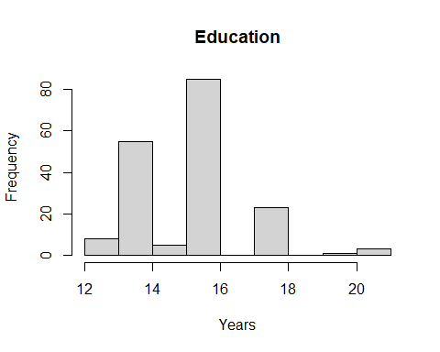
hist(data$Usage, main="Weekly Usage", xlab="Times per Week") #Shows how often customers plan to use the treadmill each week.
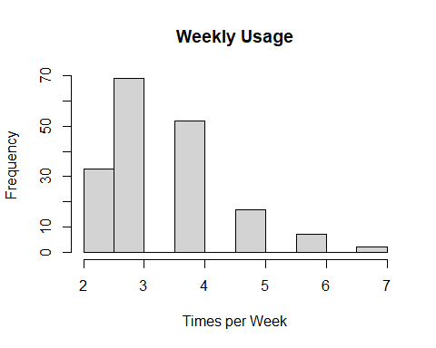
hist(data$Miles, main="Miles per Week", xlab="Miles") #Displays how many miles customers expect to run per week.
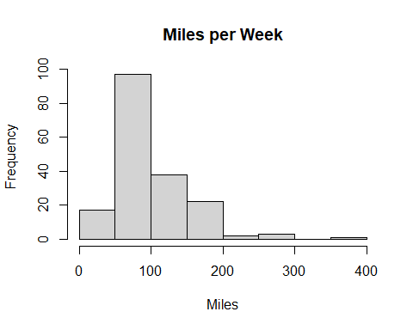

3. Categorical vs Categorical
barplot(table(data$Product, data$Gender), beside=TRUE, legend=TRUE, main="Product by Gender") #Compare how many males and females purchased each treadmill model.
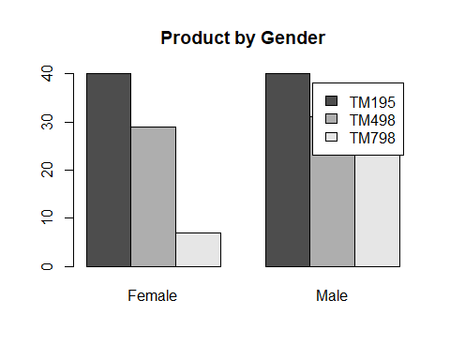
barplot(table(data$Product, data$MaritalStatus), beside=TRUE, legend=TRUE, main="Product by Marital Status") #Show how single and partnered customers differ in the treadmill models they purchased.
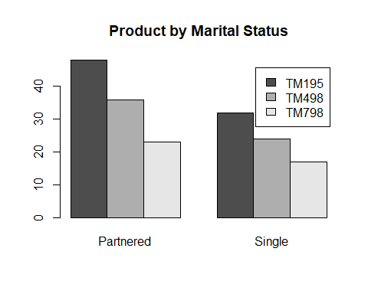

4. Numerical vs Numerical
plot(data$Usage, data$Miles, main="Miles vs Usage", xlab="Usage", ylab="Miles") #Show the relationship between weekly treadmill usage and the number of miles customers plan to run.
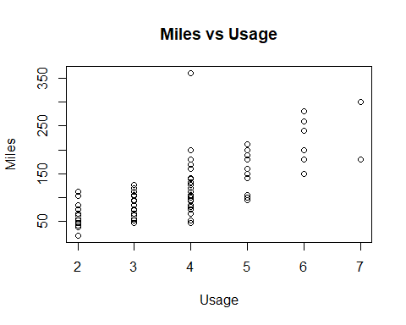
plot(data$Age, data$Income, main="Income vs Age", xlab="Age", ylab="Income") #Show how customer income varies across different ages.
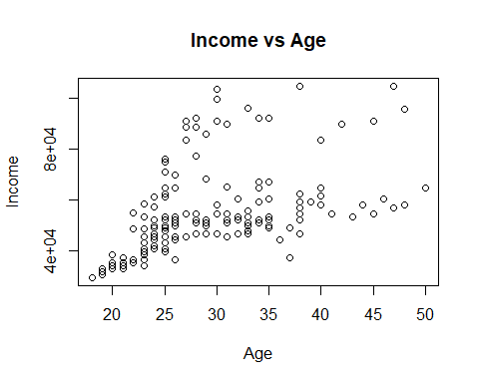

5. Categorical vs Numerical
boxplot(Income ~ Product, data=data, main="Income by Product", xlab="Product", ylab="Income") #Show how customer income levels differ across the three treadmill models.
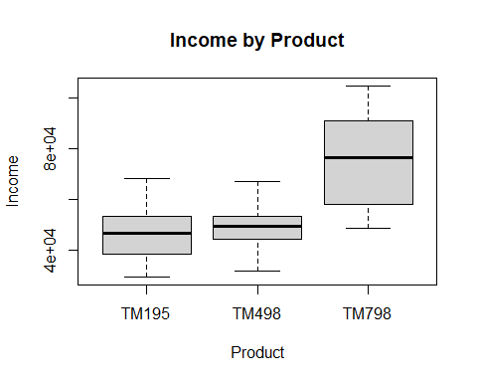
boxplot(Fitness ~ Product, data=data, main="Fitness by Product", xlab="Product", ylab="Fitness") #Compare fitness ratings for customers who purchased each treadmill model.
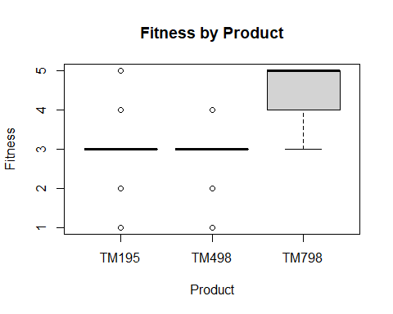
boxplot(Usage ~ Gender, data=data, main="Usage by Gender", xlab="Gender", ylab="Usage") #Show how weekly treadmill usage differs between male and female customers.
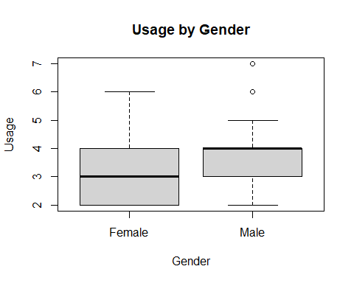

6. Simple Linear Model
model <- lm(Usage ~ Age + Income + Education, data=data) #Linear model that tries to predict weekly treadmill usage based on age, income, and education.
summary(model) #Displays the model’s results, including coefficient estimates, significance levels, and how well the model explains usage (R2).
##
## Call:
## lm(formula = Usage ~ Age + Income + Education, data = data)
##
## Residuals:
## Min 1Q Median 3Q Max
## -1.96946 -0.60755 -0.06621 0.63709 2.37361
##
## Coefficients:
## Estimate Std. Error t value Pr(>|t|)
## (Intercept) 1.763e+00 7.115e-01 2.478 0.0141 *
## Age -5.259e-02 1.099e-02 -4.786 3.59e-06 ***
## Income 4.170e-05 5.689e-06 7.330 8.05e-12 ***
## Education 6.206e-02 5.192e-02 1.195 0.2336
## ---
## Signif. codes: 0 '***' 0.001 '**' 0.01 '*' 0.05 '.' 0.1 ' ' 1
##
## Residual standard error: 0.8744 on 176 degrees of freedom
## Multiple R-squared: 0.3611, Adjusted R-squared: 0.3502
## F-statistic: 33.16 on 3 and 176 DF, p-value: < 2.2e-16

Residual Plot
plot(model$residuals, main="Residual Plot", ylab="Residuals") #Show how far the model’s predictions are from the actual usage values.
abline(h=0, col="red") #Just add a line at zero to help see whether residuals are evenly spread above and below 0.
